Morgan Grenz

Care

Draft #1

**How Jonathan Van Ness is Living his Gorgeous Normal Life with HIV**

*Jonathan Van Ness Speaks his Truth*



*<https://www.instagram.com/p/B3IcdfiAcF4/?utm_source=ig_web_copy_link>*

Queer Eye’s iconic “yas queen” Jonathan Van Ness released his memior *Over The Top: A Raw Journey to Self-Love* on September 24 where he shares his story of abuse, addiction, and living with HIV. Van Ness, 32, found out he was HIV positive at the age of 25 but decided it was time to speak up to battle the stigma that still exists around the HIV positive community.

Seven years ago, Van Ness fainted in a St. Louis hair salon while working on a client. The next day he went to Planned Parenthood and received his diagnosis.

“My worst nightmare had been realized, and I was still there,” Van Ness wrote in his memoir.

A week later at a follow up appointment, “a cute little Filipino lady,” as Van Ness describes her, gave him back his life. He immediately began taking an antiviral prescription and was undetectable in just two weeks. According to the CDC, people who have HIV and take medication daily as prescribed and maintain an undetectable viral load can live long, healthy lives and have effectively no risk of sexually transmitting the virus. Essentially, undetectable equals untransmittable.

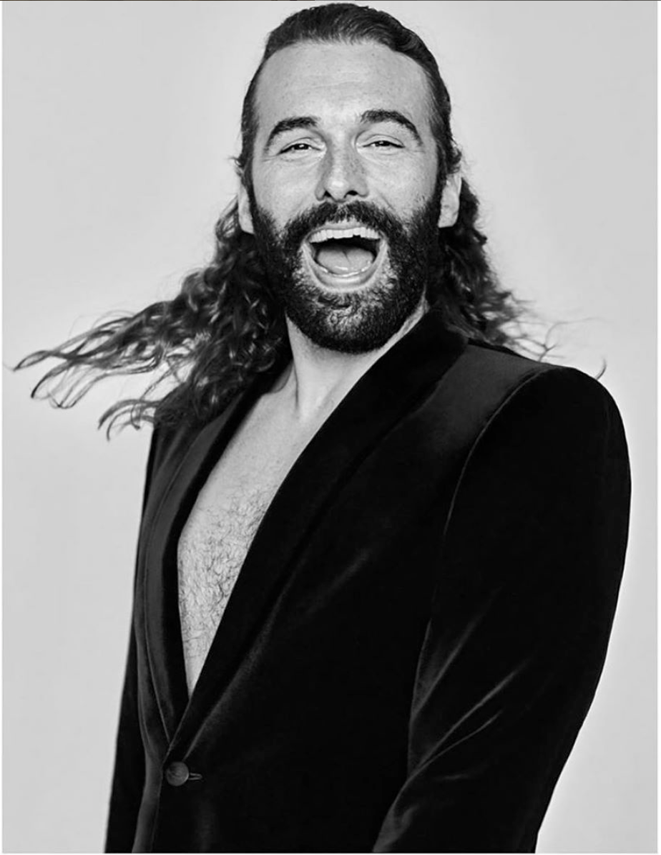

[*https://www.instagram.com/p/B2zrpg-g643/?utm_source=ig_web_copy_link*](https://www.instagram.com/p/B2zrpg-g643/?utm_source=ig_web_copy_link)

Flash forward to 2019 and JVN is living a gorgeous normal life with HIV. Van Ness told *The New York Times* that he is an out-and-proud “member of the beautiful HIV-positive community.”

He also told the times that he felt he needed to share his truth because of the current political culture.

“The Trump administration has done everything they can do to have the stigmatization of the LGBT community thrive around me,” Van Ness said.

After sharing his personal experiences, Van Ness continues to share his thoughts regarding the need for affordable and convenient sexual health care for everyone. He teamed up with Planned Parenthood to release a video encouraging people to get tested for STDs. Planned Parenthood provided more than 4.7 million tests and treatments for STDs last year, including 740,000 HIV tests, Van Ness told viewers.

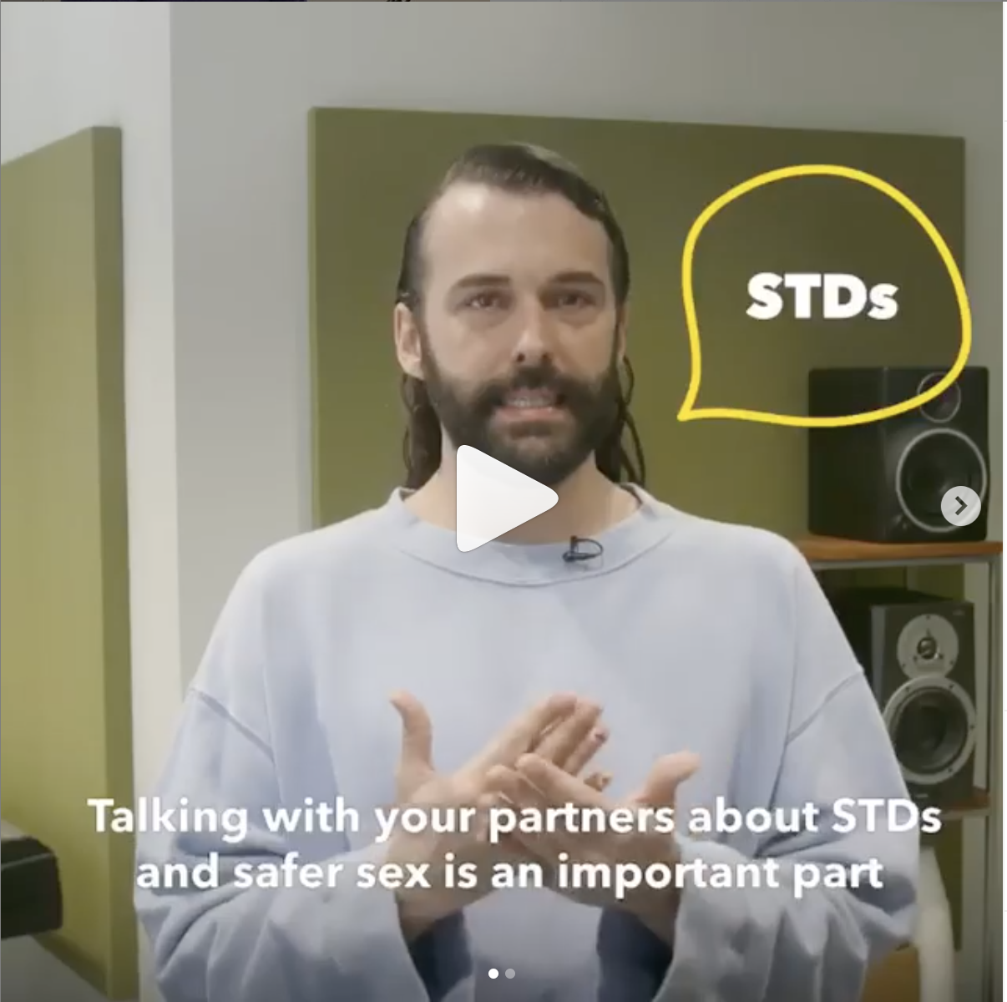

[*https://www.instagram.com/p/B2xkhTZg3Xw/?utm_source=ig_web_copy_link*](https://www.instagram.com/p/B2xkhTZg3Xw/?utm_source=ig_web_copy_link)

The Trump administration’s plan to force Planned Parenthood out of the Title X Family Planning Program would make it harder for people to receive free or low-cost care. This federal grant program was created in 1970 to provide family planning services and preventive health services, prioritizing low-income individuals and families.

“Healthcare shouldn’t be for profit ever, it’s a human right,” Van Ness said in a tweet about his decision to endorse Sen. Elizabeth Warren. He recalls misplacing his HIV medication last month and finding out it cost $3,500 out of pocket to replace them. This price truly is out of pocket, honey.

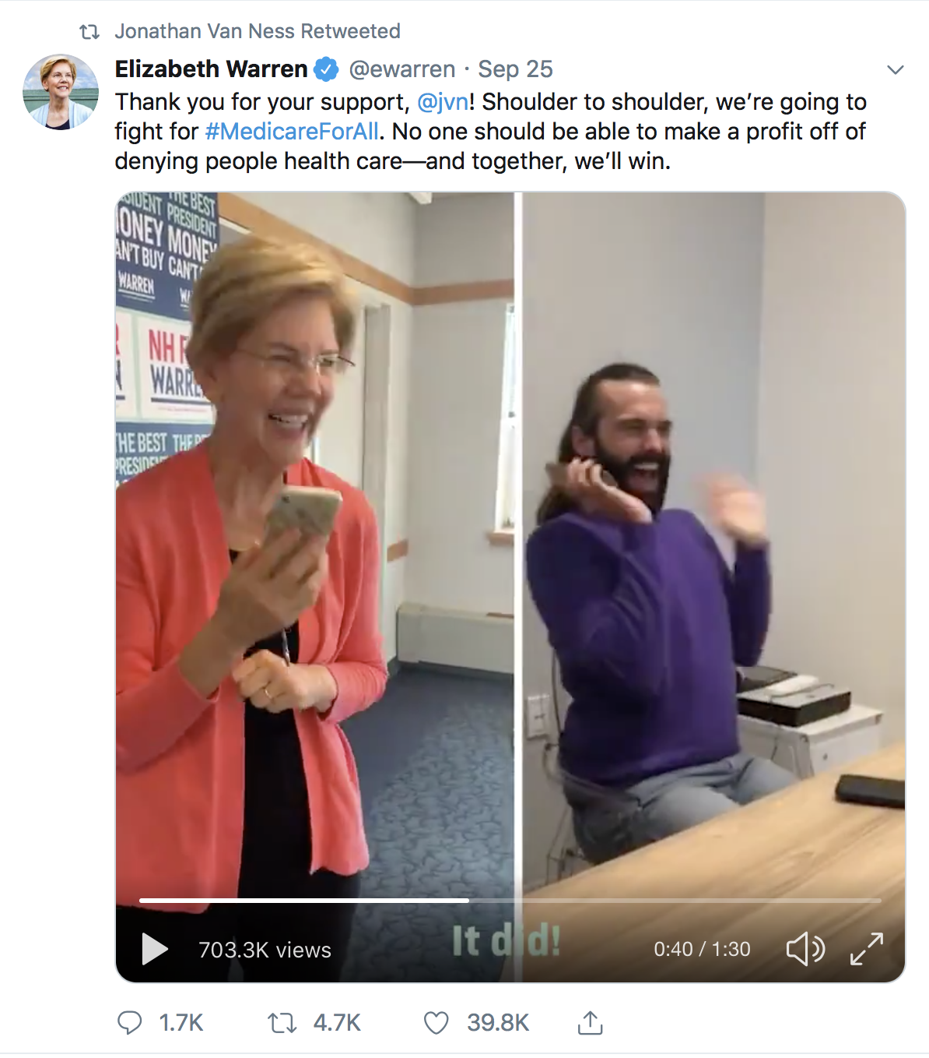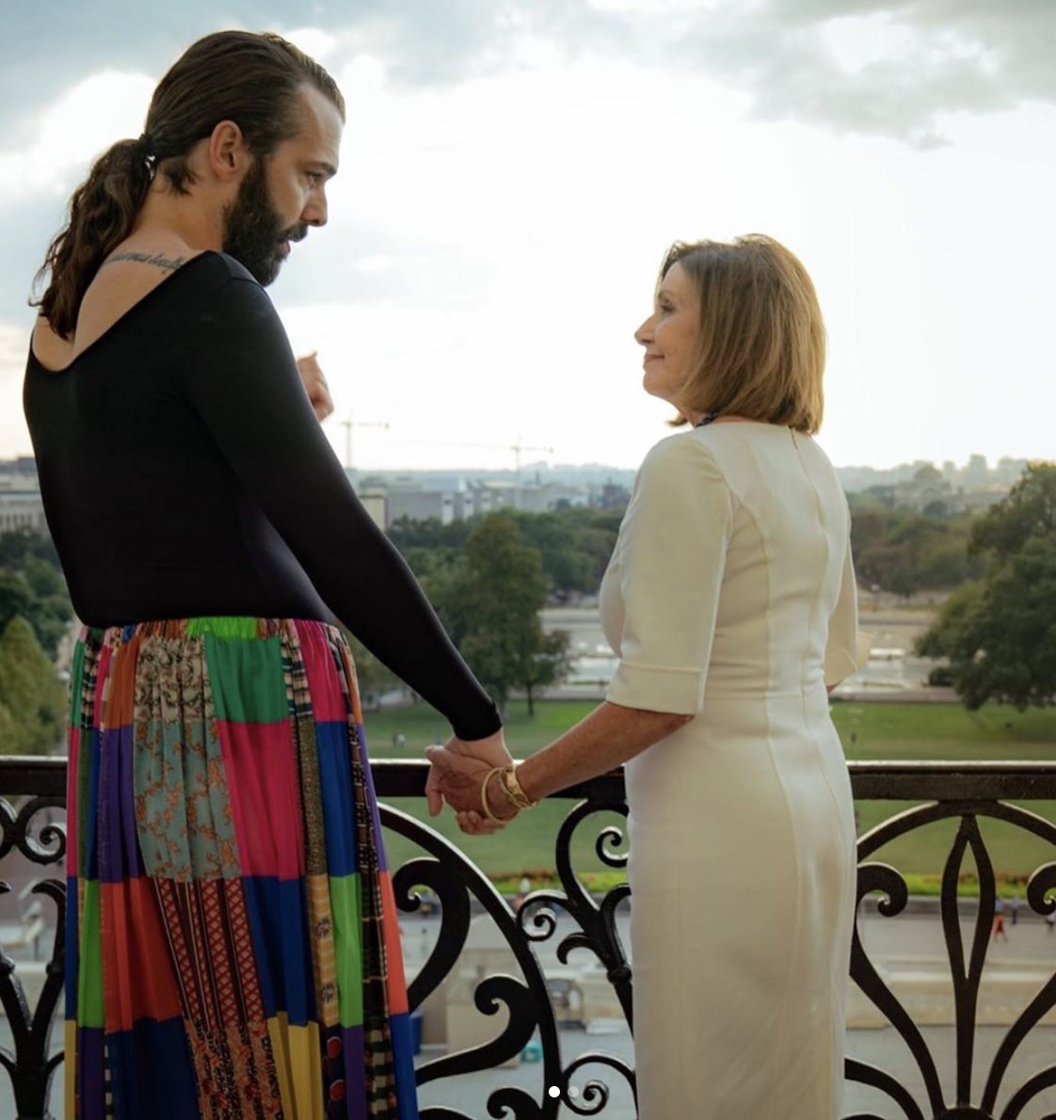

[*https://www.instagram.com/p/B268JoVAiEY/?utm_source=ig_web_copy_link*](https://www.instagram.com/p/B268JoVAiEY/?utm_source=ig_web_copy_link)

[*https://twitter.com/ewarren/status/1177037779508899840?s=20*](https://twitter.com/ewarren/status/1177037779508899840?s=20)

Van Ness also took a trip to capitol hill September 26 to meet with speaker Nancy Pelosi to discuss access to PrEP, living with HIV, and the Equality Act.

“As a thirty-two-year-old living with HIV, with the privilege and microphone I now have, I rail against the way this country’s government responded-and continues to respond-to the HIV/AIDS crisis,” Van Ness wrote. “So many people let it happen right in front of their faces and didn’t lift a finger to help.” *Over the Top* seems to be just a spark in the wildfire of conversations and action to come from the star.

